21.73: a)
Also the number of ions is 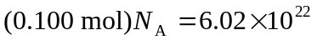 so the charge is: The force between two such charges is:
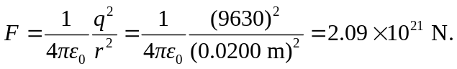
b)
c) With such a large force between them, it does not seem reasonable to think the sodium and chlorine ions could be separated in this way.

